SIMATS ENGINEERING (SAVEETHA SCHOOL OF ENGINEERING)
Department of Computer Science and Engineering
CO2 ASSESSMENT TOOL 1 – Scenario-Based Requirement Analysis

Course Code: | CSA10 / CSA1005 | Course Title: | Software Engineering
CO Assessed: | CO2 | Assessment: | Assessment Tool 2 – Scenario-Based Requirement Analysis
Weightage: | 20% | Total Marks: | 25
CO2 Statement: | Perform detailed requirements analysis, design scalable architectures, and prioritize features with a focus on cross-disciplinary skills
Student Name: | S. Rohit Ram | Register No.: | 1922260146
Date: | 27.10.26 | Duration: | 60 minutes

Code of Conduct
I __________________________ (Name / Reg No) certify that this submission is my original work and that I have adhered to the guidelines specified for this assessment. I understand that any violation of academic integrity rules will result in disciplinary action.
Signature of the Student: _________________________

AGRISHARE – SCENARIO-BASED REQUIREMENT ANALYSIS
Software Requirement Specification (SRS)
Project: AgriShare – Agricultural Equipment Sharing Platform
Student Name: S. Rohit Ram Register No.: 1922260146

1. Introduction

1.1 Purpose
This Software Requirement Specification describes AgriShare, a proposed platform that connects farmers who need agricultural equipment with owners who can make equipment available for rent. It defines the system scope, users, features, quality requirements, data, interfaces, assumptions, constraints, and validation checks.

1.2 Business Domain and Background
AgriShare belongs to agricultural technology and equipment rental/sharing. Farmers may need tractors, seeders, harvesters, sprayers, or other machinery only at particular times. Buying equipment can be costly, while owners may have machinery that remains unused between farming seasons. AgriShare aims to make equipment discovery and rental coordination easier.

2. Problem Description
Farmers may rely on personal contacts or manual phone calls to find machinery. Information about equipment type, rental price, location, and availability can be scattered or outdated. Equipment owners may also find it difficult to organize requests, track rental dates, and maintain rental records. AgriShare proposes one place to publish equipment listings, request bookings, and track rental activity.

2.1 Stakeholders
Stakeholder | Need / Interest | Interaction with AgriShare
Farmer / renter | Find suitable equipment at a clear price | Search listings, view details, request bookings, track status, leave feedback
Equipment owner | Rent out available equipment and manage requests | Create listings, set prices and availability, accept/reject requests
Administrator | Maintain safe and orderly platform operation | Review users, listings, reports, and disputes
Payment gateway (if integrated) | Process online transactions securely | Return payment success/failure status

2.2 System Objectives
1. Allow farmers to search equipment using relevant filters.
2. Allow owners to publish and maintain equipment listings.
3. Support booking requests and clear booking-status updates.
4. Record rental charges and payment status where payment integration is enabled.
5. Maintain booking history and user ratings or reviews.
6. Provide administrative functions for reported problems and inappropriate listings.

3. Scope of the System

3.1 In Scope
• User registration, login, and profile management.
• Equipment listings with name, category, description, location, rental rate, and availability.
• Search and filtering by equipment type, location, price, and available dates.
• Booking requests, owner responses, cancellation status, and rental-history viewing.
• Payment-status recording through a payment provider if online payment is included.
• Ratings, reviews, issue reports, and basic administration.

3.2 Out of Scope
• Manufacturing or repairing agricultural equipment.
• Guaranteeing the physical condition of equipment without a separate inspection process.
• Automatic delivery, GPS tracking, insurance, or loan services unless added as separately approved features.
• Resolving every rental dispute automatically; administrators can record and review reported issues.

4. Functional Requirements
Functional requirements specify what AgriShare must do. These are proposed requirements based on the AgriShare concept and should be adjusted if the assigned scenario specifies additional features.
ID | Functional requirement
FR-01 | The system shall allow users to register using the required account details.
FR-02 | The system shall authenticate registered users before providing account-specific functions.
FR-03 | The system shall allow users to view and update permitted profile information.
FR-04 | The system shall allow equipment owners to create a listing with equipment name, category, description, location, rental rate, and availability.
FR-05 | The system shall allow owners to edit, pause, or remove their own listings, subject to active bookings.
FR-06 | The system shall allow farmers to search and filter listings by equipment type, location, rental price, and availability.
FR-07 | The system shall display listing details and stated rental terms.
FR-08 | The system shall allow a farmer to request equipment for a selected rental period.
FR-09 | The system shall check availability and prevent overlapping confirmed bookings for the same equipment.
FR-10 | The system shall allow the owner to accept or reject a booking request.
FR-11 | The system shall display booking statuses such as pending, confirmed, rejected, cancelled, and completed.
FR-12 | The system shall support booking cancellation according to the platform's defined policy.
FR-13 | If a payment gateway is integrated, the system shall record the returned transaction status for the booking.
FR-14 | The system shall allow users to view their relevant current and previous bookings.
FR-15 | The system shall allow eligible users to submit ratings and reviews after a completed rental.
FR-16 | The system shall allow users to report a listing or rental-related issue.
FR-17 | The administrator shall be able to review reports and take permitted action on users or listings.
FR-18 | The system shall record important booking-status changes for traceability.

5. Non-Functional Requirements
ID / Category | Non-functional requirement
NFR-01 Performance | Common searches and pages should respond within an agreed target, for example three seconds under expected load.
NFR-02 Security | Passwords must be stored securely, and access must be controlled according to user role.
NFR-03 Privacy | Personal and transaction information must only be accessible to authorized users and services.
NFR-04 Reliability | The system should preserve booking records and handle failed requests without creating duplicate confirmed bookings.
NFR-05 Usability | The interface should use clear labels, simple navigation, and understandable validation messages.
NFR-06 Availability | The service should target an agreed availability level, such as 99% monthly excluding planned maintenance.
NFR-07 Scalability | The system design should allow growth in users, listings, and bookings.
NFR-08 Maintainability | The software should be modular, documented, and testable.
NFR-09 Compatibility | The platform should work in commonly used modern mobile and desktop browsers.
NFR-10 Backup and recovery | Regular backups and a recovery procedure should protect important records.

6. Actors and Use Cases

6.1 Actors
• Farmer / renter – searches for equipment, views details, requests bookings, checks status, and submits feedback.
• Equipment owner – creates and maintains listings, sets availability and price, and responds to booking requests.
• Administrator – reviews user/listing reports and manages permitted moderation actions.
• Payment gateway – an external actor only if online payment is part of the implementation.

6.2 Major Use Cases
Use case | Actor(s) | Description
UC-01 Register / log in | Farmer, owner, administrator | The user registers or enters credentials; the system validates the details and provides role-appropriate access.
UC-02 Search equipment | Farmer | The farmer enters filters and views matching active listings.
UC-03 Manage equipment listing | Owner | The owner creates, edits, pauses, or removes a listing.
UC-04 Request booking | Farmer | The farmer selects equipment and dates; the system checks availability and creates a pending request.
UC-05 Respond to booking | Owner | The owner accepts or rejects the request and the system updates the status.
UC-06 Process payment | Farmer, payment gateway | If integrated, the payment provider processes the transaction and returns a result.
UC-07 View rental history | Farmer, owner | The system shows bookings relevant to the signed-in user.
UC-08 Submit review | Eligible renter / owner | After a completed rental, an eligible user submits a rating or review.
UC-09 Manage reports | Administrator | The administrator reviews reported listings or rental issues and records action.

6.3 Use Case Diagram
The following diagram shows the main proposed interactions between AgriShare and its actors.
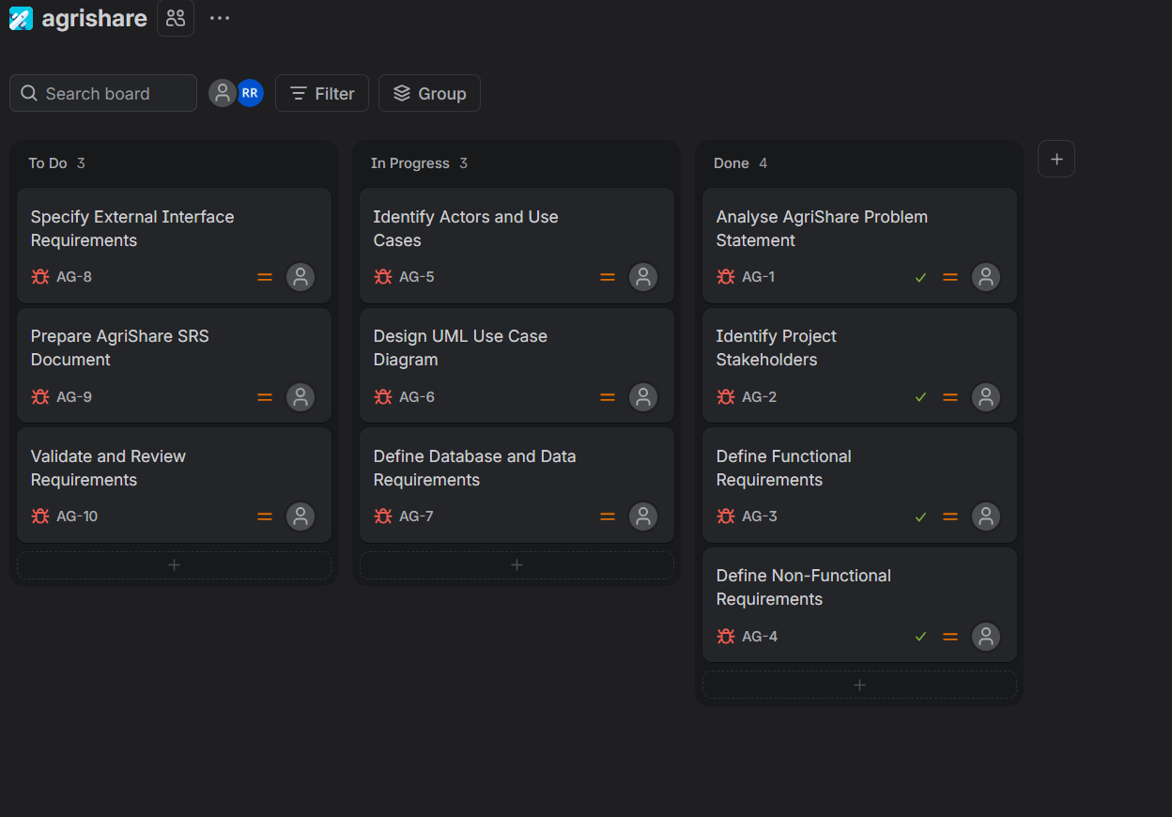
Figure: AgriShare project task progress board in Jira
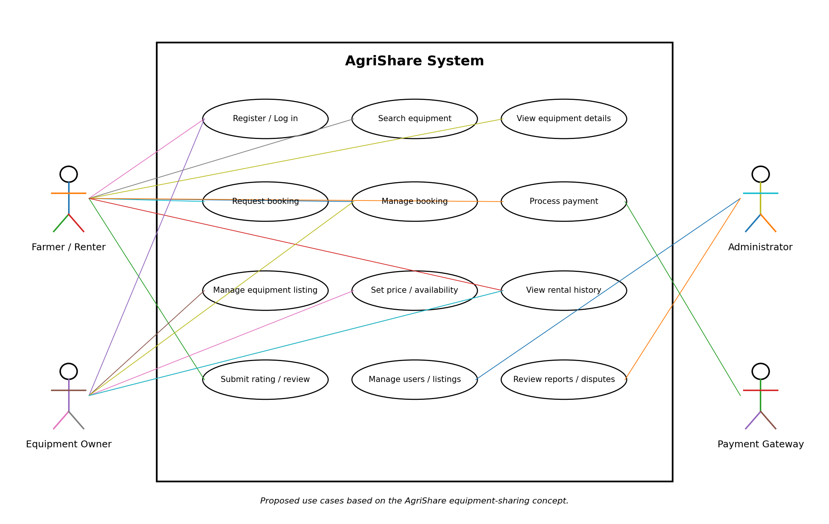

7. Software Requirement Specification Details

7.1 Data Requirements
• User: user ID, name, contact details, login identifier, password hash, role, and account status.
• Equipment listing: listing ID, owner ID, equipment name/category, description, location, rental rate, availability, and status.
• Booking: booking ID, renter ID, listing ID, rental period, booking status, agreed charge, and timestamps.
• Payment: payment reference, booking ID, amount, status, provider transaction reference, and timestamp; the platform should not store sensitive card credentials.
• Review: review ID, related completed booking, reviewer ID, rating, comment, and date.
• Report: report ID, reporter, related listing/booking, description, status, and administrative action.
Data integrity rules: every listing must belong to an owner; each booking must reference a renter and a listing; confirmed bookings must not overlap for the same equipment; and reviews must be linked to eligible completed rentals.

7.2 External Interface Requirements
• User interface: registration/login, search results, equipment details, listing management, booking status, history, reviews, and administration pages.
• Software interface: a database for persistent records and an external payment gateway only if online payment is implemented.
• Communication interface: secure HTTPS communication should be used in a deployed system.
• Hardware interface: no special hardware is required for the basic web platform; users need a compatible phone or computer and network access.

7.3 System Features
Feature | Description
Account management | Registration, login, profile maintenance, and role-based access.
Equipment catalogue | Create, update, search, filter, and view equipment listings.
Booking management | Request rentals, check availability, accept/reject requests, and track booking status.
Payment status | Display or record transaction status if payment integration is implemented.
Rental history and reviews | View previous rentals and submit eligible ratings or reviews.
Administration | Review reports, moderate listings, and manage user accounts within permitted roles.

8. Assumptions and Constraints

8.1 Assumptions
• Users have access to a phone or computer and an internet connection.
• Equipment owners provide accurate descriptions, prices, location, and availability.
• Users coordinate equipment handover and return according to agreed platform rules.
• The platform will define cancellation, deposit, damage, and dispute policies before launch.
• Online payment depends on the availability of a suitable payment provider.

8.2 Constraints
• Technical: available development tools, database, hosting, and third-party service interfaces may limit implementation.
• Operational: equipment handover and return may require coordination outside the platform.
• Economic: development, hosting, maintenance, payment fees, and support must fit the available budget.
• Legal: personal-data protection, electronic payments, and applicable local rules must be considered.
• Time-related: assessment and project deadlines may restrict the number of features delivered.
• Data quality: search results depend on correct details and availability supplied by owners.

9. Requirement Completeness and Consistency Validation

9.1 Validation Checklist
• All identified stakeholders have relevant use cases.
• Each functional requirement is clear and can be tested.
• Booking and availability requirements do not contradict one another.
• Non-functional requirements include measurable targets where practical.
• Data records support the features and have clear relationships.
• Payment failure and external-service failure cases are considered where applicable.
• Security and privacy requirements protect personal and transaction data.
• Cancellation, refund, deposit, damage, and dispute rules are defined before implementation.

9.2 Potential Gaps and Improvements
• Confirm whether the assigned AgriShare scenario includes delivery, GPS tracking, deposits, equipment inspection, or only basic rental coordination.
• Specify exact cancellation and refund rules.
• Define whether users or equipment owners must be verified.
• Set realistic performance and availability targets based on expected usage.
• Test booking conflicts, failed payments, rejected bookings, and unauthorized access.

9.3 Sample Acceptance Checks
1. When a farmer searches using filters, the system displays only matching active listings.
2. When equipment has a confirmed booking for a selected period, a conflicting request cannot become a confirmed booking.
3. When an owner rejects a booking, the renter can see the rejected status.
4. When payment fails, the system does not show the transaction as successfully paid.
5. When a non-administrator tries to access an administrator-only page, access is denied.

10. Conclusion
AgriShare is proposed as a platform that connects farmers who need agricultural equipment with owners who can rent out available machinery. This analysis defines the problem, objectives, scope, functional and non-functional requirements, actors, use cases, data, interfaces, system features, assumptions, constraints, and validation checks. The requirements should be checked against the exact AgriShare scenario assigned by the instructor before final submission.
Rubrics for Calculation
Criteria | Excellent (4 Marks) | Good (3 Marks) | Satisfactory (2 Marks) | Needs Improvement (1 Mark)
Scenario Understanding and Problem Analysis (30%) | Demonstrates thorough understanding of the scenario, stakeholders, objectives, and business context with clear analysis. | Demonstrates good understanding with minor omissions. | Basic understanding with limited analysis. | Poor understanding; major aspects missing or incorrect.
Functional and Non-Functional Requirement Identification (25%) | Clearly identifies comprehensive, accurate, and well-classified functional and non-functional requirements. | Identifies most requirements with minor classification errors. | Identifies only basic requirements; several omissions. | Requirements are incomplete, inaccurate, or poorly classified.
Actor Identification and Use Case Modelling (20%) | Correctly identifies all relevant actors and use cases; use case diagram is complete, accurate, and follows UML standards. | Most actors and use cases identified; diagram has minor errors. | Limited actors/use cases identified; diagram partially correct. | Actors/use cases missing or incorrect; diagram absent or inaccurate.
Software Requirement Specification (SRS) Documentation (15%) | SRS is well-structured, complete, professionally organized, and includes all required sections. | SRS is organized with minor missing sections or formatting issues. | SRS includes only essential sections with limited detail. | SRS is incomplete, poorly organized, or lacks essential components.
Assumptions, Constraints, and Requirement Validation (10%) | Clearly identifies realistic assumptions and constraints; validates requirements for completeness, consistency, and ambiguity with appropriate justification. | Identifies most assumptions and constraints; validation is adequate. | Limited assumptions/constraints; validation is superficial. | Assumptions, constraints, and validation are missing or incorrect.

Criteria | Mark
Scenario Understanding and Problem Analysis (30%) | /5
Functional and Non-Functional Requirement Identification (25%) | /5
Actor Identification and Use Case Modelling (20%) | /5
Software Requirement Specification (SRS) Documentation (15%) | /5
Assumptions, Constraints, and Requirement Validation (10%) | /5
TOTAL | /25

